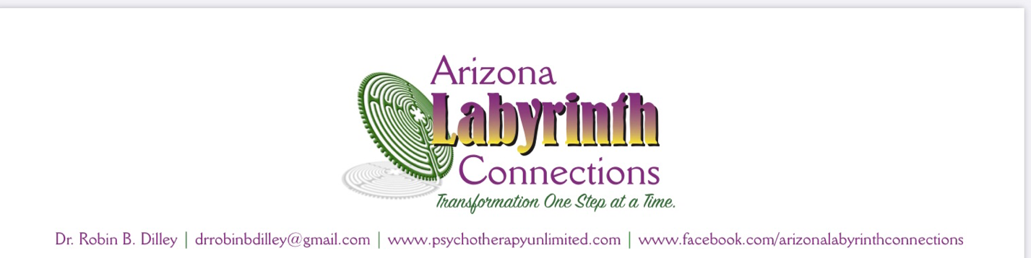
Hello!

It is a pleasure for me to introduce the Labyrinth to you today and hope that you find this beautiful tool a wonderful comfort and a resource for not only your healing journey, but a tool of comfort and spirituality in many ways in the future.

A bit of my bio for you to review if you’d like:

Dr. Dilley is an Arizona Licensed Psychologist, Author, and an Advanced Veriditas Labyrinth Facilitator. She now offers psychotherapy and coaching sessions within the comfort and privacy of your own home or office. Tele-medicine has become a viable, personal, and professional way to do the in-depth and personal work of intense psychotherapy. You no longer need to spend valuable time commuting across town to a session. Now, you can fit psychotherapy into any part of your day! With just a click of a button, Dr. Dilley can appear virtually wherever you go. Sessions are accessed by clicking a free, HIPAA-compliant link on your computer, tablet or smart phone, without the need of downloading any additional applications.

Dr. Dilley specializes in a variety of psychotherapy services including depression, anxiety, trauma, grief, overwhelm, or family-of-origin work. Together, she will help you take that deep dive to soothe your hurting soul. As a cancer survivor and thriver herself (diagnosed in 1999), she also works extensively with cancer patients. In fact, it was her own cancer journey that led her to explore and fall in love with the Labyrinth.

Currently, Dr. Dilley’s passion is introducing the Labyrinth as a healing tool through the many workshops and groups she teaches. Arizona Labyrinth Connections is her newest arm of her psychotherapy and spiritual consulting practice and she is excited to share the transformational power of the Labyrinth with you

You can reach Dr. Dilley at drrobinbdilley@gmail.com, she welcomes your comments and questions! Additionally, be sure to sign up for her weekly emailed newsletter to receive inspiration and educational motivation to stay on your path. Sign up by texting: DRDILLEY to 22828.

Warmly,
Dr. Robin B. Dilley

